  - The Skinny Chef Client Appreciation

Madi Gabriele
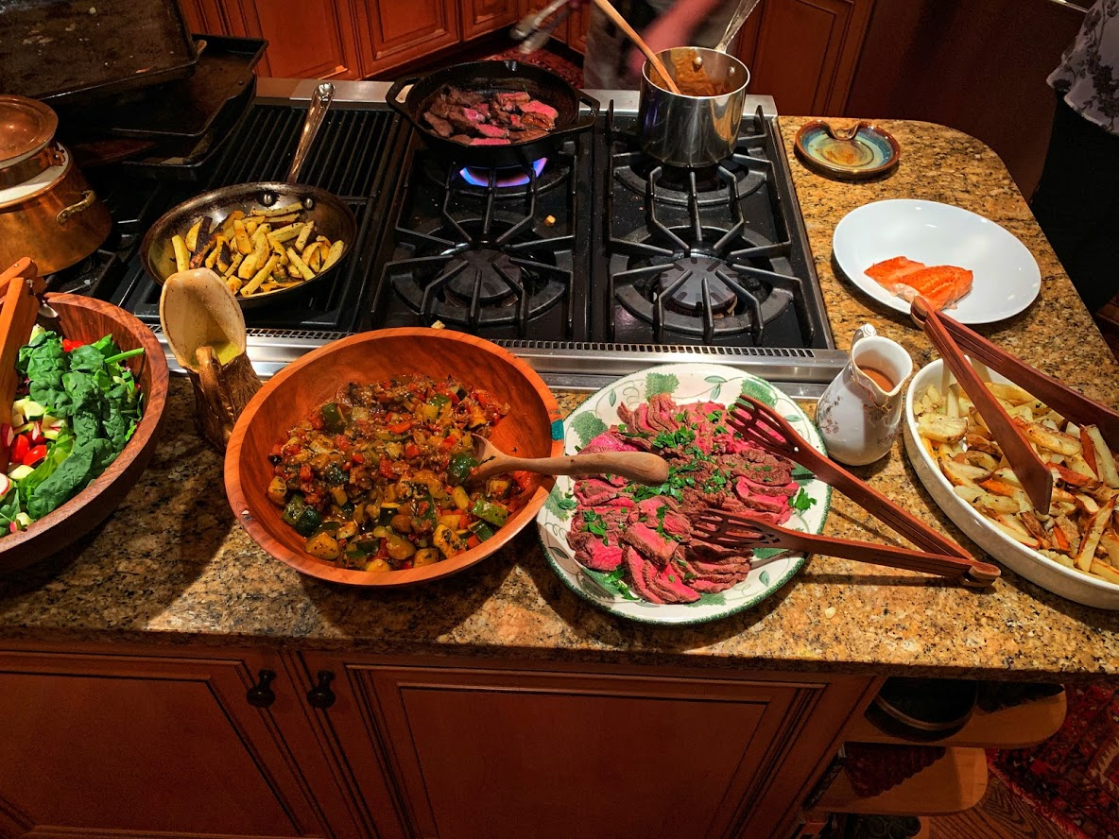
Became A Client August 3rd 2019

Word Of Mouth
“Cooking Classes, Dinner Parties, Family Meals…..”
“I have used Chef Heather Green's personal chef services for a variety of occasions at my home ~ from cooking classes, dinner parties, family meals to Book Club. I would describe her work as masterful, beautiful, bountiful, and beyond delicious. Heather cooks with heart and soul and you can taste it and see it in everything she does ~ always a big hit with my family and friends. More than this, her presentation of the food is simple and artistic and full of love. I really can't say enough good things about her work and being a guest in my own home tops it all off. She is a gift!”

